SSTACK SEGMENT STACK
DW 32 DUP(?)
SSTACK ENDS
CODE SEGMENT
ASSUME CS:CODE
START: PUSH DS
MOV AX,0000H
MOV DS,AX
MOV AX,OFFSET MIR7
MOV SI,003CH
MOV [SI],AX
MOV AX,CS
MOV SI,003EH
MOV [SI],AX
CLI
POP DS
MOV AL,11H
OUT 20H,AL
MOV AL,08H
OUT 21H,AL
MOV AL,04H
OUT 21H,AL
MOV AL,01H
OUT 21H,AL
MOV AL,6FH
OUT 21H,AL
STI
AA1: NOP
JMP AA1
MIR7: STI
MOV DL,34H
MOV AH,02H
INT 21H

MOV AX,20H
OUT 20H,AL
IRET
CODE ENDS
END START

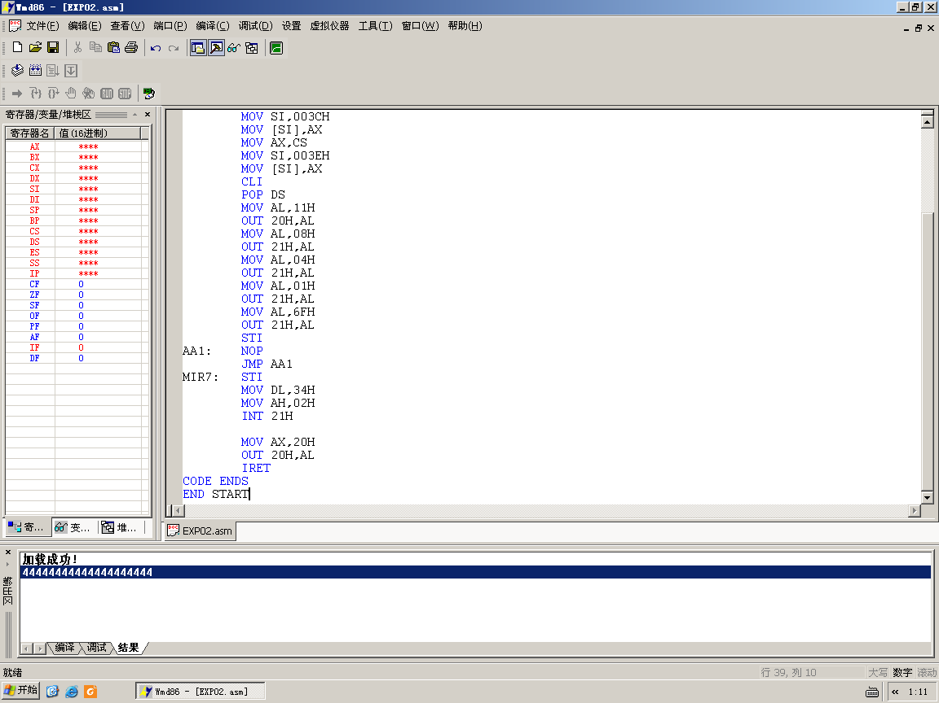

第三个实验
基本输入输出
SSTACK SEGMENT STACK
DW 32 DUP(?)
SSTACK ENDS
CODE SEGMENT
ASSUME CS:CODE
START:
MOV DX,0646H
MOV AL,90H
OUT DX,AL
AGAIN: MOV DX,0640H
IN AL,DX
MOV DX,0642H
OUT DX,AL
JMP AGAIN
CODE ENDS
END START

跑马灯
SSTACK SEGMENT STACK
DW 32 DUP(?)
SSTACK ENDS
CODE SEGMENT
ASSUME CS:CODE
START:
MOV DX,0646H
MOV AL,80H
OUT DX,AL

AGAIN:
MOV AL,01H
MOV CX,8
RIGHT:
MOV DX,0640H
OUT DX,AL
CALL DELAY
ROL AL,1
LOOP RIGHT
MOV AL,0
MOV DX,0640H
OUT DX,AL
MOV CL,8

MOV AL,01H
LEFT:
MOV DX,0642H
CALL DELAY
OUT DX,AL
CALL DELAY
ROL AL,1
LOOP LEFT
MOV AL,0
MOV DX,0642H
OUT DX,AL
JMP AGAIN
DELAY:PUSH CX
MOV CX, 0F000H
AA2: PUSH AX
POP AX
LOOP AA2
POP CX
RET
CODE ENDS

END START

